IE260 Homework #1 Report

20150359 Chiyoon Park

1. Class Diagram

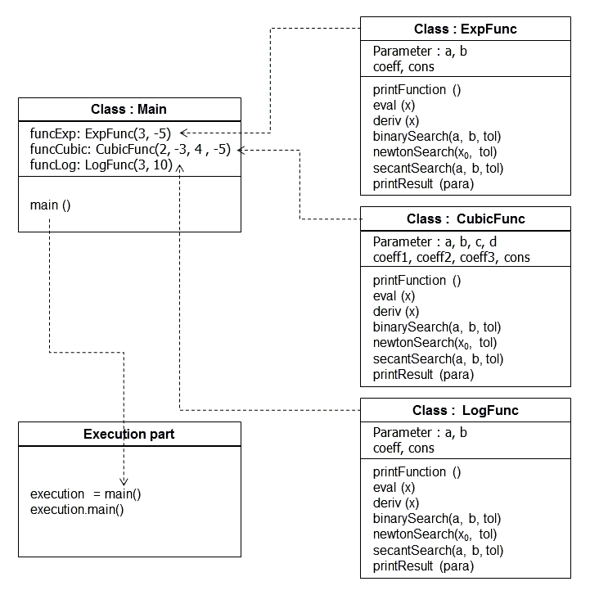

2. Output

